W368R-How to choose wireless WAN(WISP) mode for the router?
Product line: Wireless Question category: Function configurations

Q:Why do we choose the Wireless WAN(WISP) mode?
A：Sometimes we want the router to be a wireless repeater to the uplink wireless signal. You can achieve this through choose Wireless WAN for the router.

The conncetion structure as follows:

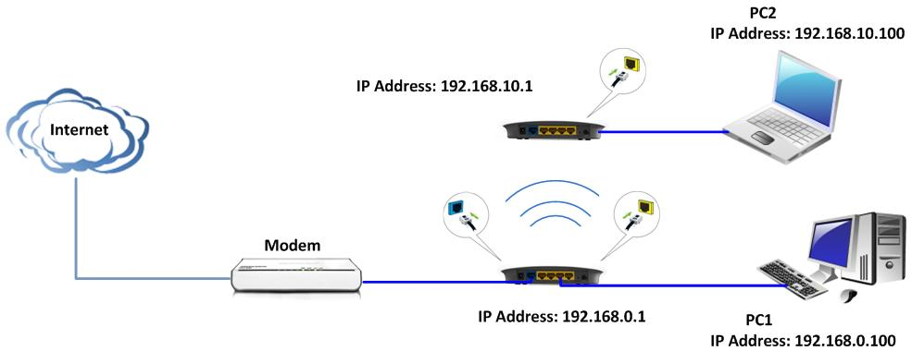

Key points:
The LAN IP address should be in defferent network segment. For example,if the LAN IP of the uplink router is 192.168.10.1, you can set the secondary router’s LAN IP as 192.168.0.1.

Steps are as below:
- Login to the router’s homepage by typing http://192.168.0.1 in the address bar in web browser.
- Click Advanced settings→WAN Medium Type, you’ll see a page as follows.

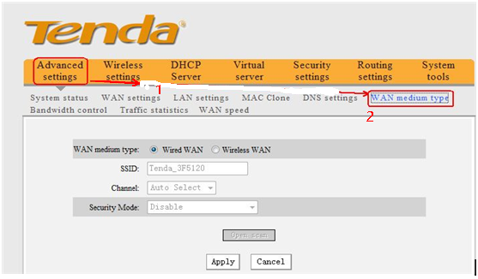

- Choose Wireless WAN and click Open Scan, you will find the uplink wireless router’s signal.

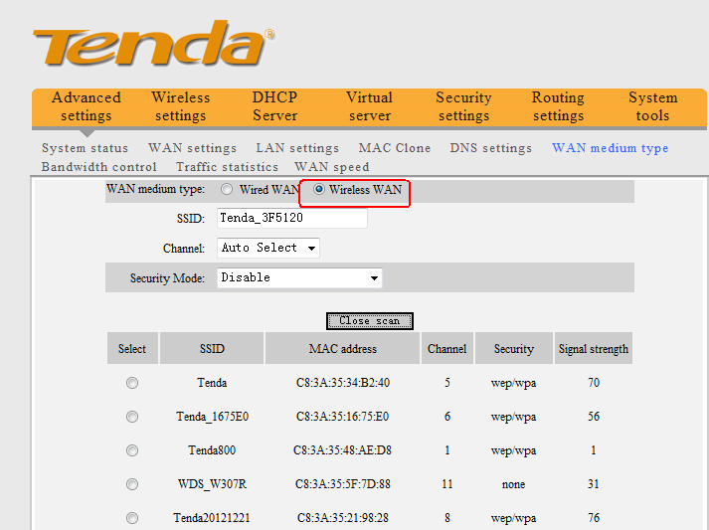

4．Choose the uplink router’s wireless signal and click OK.
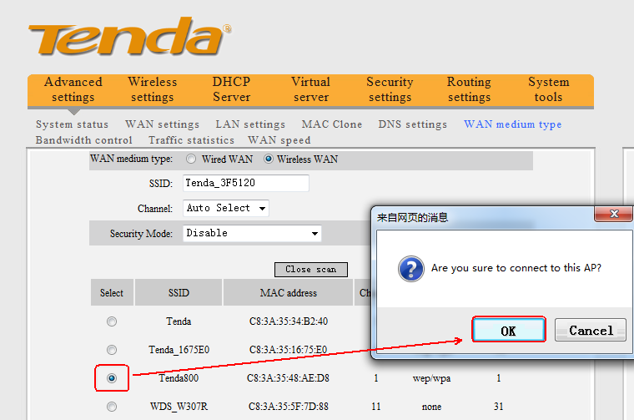

- The uplink wireless router’s SSID will be added to the blank of SSID, then please choose the same Security Mode/encryption type as the uplink wireless router, and please input the uplink wireless router’s security key in the blank of Pass Phrase. Then click Apply to save the settings.
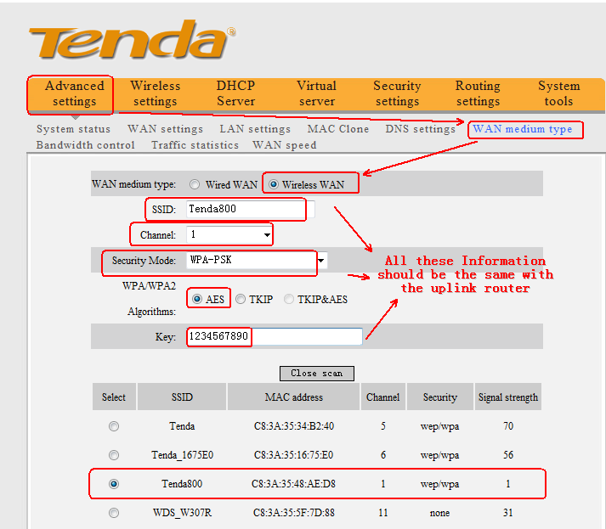
Note:
The router’s LAN IP should be in different IP network with uplink wireless router’s LAN IP.
For example:
Uplink wireless router’s LAN IP: 192.168.10.1
Router’s LAN IP: 192.168.0.1

